MagulaPlan (Magula.lk) — Submission Checklist & Access Links
In accordance with the CCS2313 Project Management — Additional Submission Guidelines, this document compiles all required external links, repository access, and verification credentials into a single reference document.
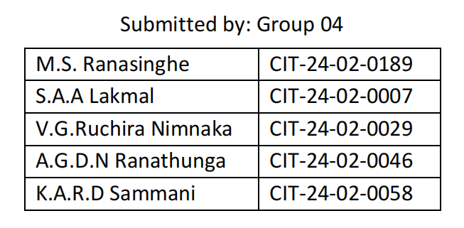
1. Required Links & Access Configuration
1.1 Figma File
- Link: https://www.figma.com/design/Mqc0NW1ampHiNFoExxsvo1/Group-04?node-id=0-1&t=eACvY8uO0tjc4rtB-1
- Access Level: Configured as "Anyone with the link can view" (No invite or account needed).
- Repository Backups: Also available in repository at `docs/MagulaPlan Wireframes.pdf` and `docs/MagulaPlan Wireframes(Mobile).pdf`.
__________________________________________________________________________
1.2 GitHub Repository
- Link: https://github.com/maheensayuru/MagulaPlan
- Visibility: Set to Public.
- Branches: `main` (Production release), `refactor/ui-redesign-storybook-romance` (Active feature branch).
- Sanitization Audit: Verified that all `.env` secrets, database root passwords, and private API keys have been removed from tracking.
__________________________________________________________________________
1.3 Jira Project Direct Access
- Project URL:
https://magulaplan.atlassian.net/jira/software/projects/MAG/list?jql=project%20%3D%20%22MAG%22%20AND%20(statusCategory%20!%3D%20Done%20OR%20(statusCategory%20%3D%20Done%20AND%20statusCategoryChangedDate%20%3E%3D%20-2w))%20ORDER%20BY%20status%20ASC
- Assigned Evaluator Email: `chamathkara.k@sltc.ac.lk`
- Access Granted: Added as Viewer under Jira Cloud $\rightarrow$ *Project Settings* $\rightarrow$ *People* $\rightarrow$ *Add People*.
__________________________________________________________________________
1.4 Test Cases Documentation
- Source Artifact: `Magula.lk/docs/MagulaPlan_Test_Cases.docx` & `qa/test-summary.md’ (inside the repo)
- Coverage: 142 automated JUnit backend tests (100% pass) + 13 automated Vitest frontend tests (100% pass) + 46 comprehensive system test scenarios across 7 functional modules.
- Online Link: https://docs.google.com/document/d/1h9r9_w4wIUzV2EqF_Eb0WpU6avJGQBRR/edit?usp=drive_link&ouid=100696604542968906673&rtpof=true&sd=true (Set to *"Anyone with the link can view"*).
__________________________________________________________________________
1.5 Functional & Non-Functional Requirements Document
- Source Artifact: `MagulaPlan_Complete_Project_Development_Documentation.docx` (Sections 3, 4, 16, 17).
- Online Link: https://drive.google.com/file/d/1zzpthVPDKEzmpu2sp2_UZOEkuwJqc18L/view?usp=drive_link (Set to *"Anyone with the link can view"*).
__________________________________________________________________________
1.6 High-Level Architecture Diagram
- Source Artifacts: `Magula.lk/docs/High_Level_Architecture_Diagram.png` (High-Res 300 DPI Rendering).
- Online Link: https://drive.google.com/file/d/1ARWS21GQpVtRWoIHbxjyBwgU1t959j9H/view?usp=drive_link (Set to *"Anyone with the link can view"*).

__________________________________________________________________________
1.6 Other rescources
- API_Design: https://docs.google.com/document/d/19tZAw4b2AKFNmSVUttotYQdq4eB77i1r/edit?usp=drive_link&ouid=100696604542968906673&rtpof=true&sd=true
- Cost_Estimation and Budget.docx: https://docs.google.com/document/d/1E1ZQhA02Pp0dNQ3R8PHBckoaLuQT19aG/edit?usp=drive_link&ouid=100696604542968906673&rtpof=true&sd=true
- Database Schema & ER: https://drive.google.com/file/d/1DDySVm6XO2lFezjJWLUu5QmEzThg2BAj/view?usp=drive_link , https://drive.google.com/file/d/1ok3G1e8JMQwcf0PngfaQX7ku-y_WPet8/view?usp=drive_link

__________________________________________________________________________
2. Live Deployment Endpoints & Demo Credentials
Endpoint / Resource | Live URL | Notes / Configuration
**Live Frontend (Primary Mirror)** | `https://magulaplan.infinityfreeapp.com/?i=1` | Deployed on Apache storage with SPA `.htaccess` routing and dynamic API host fallback.
**Live Frontend (Edge CDN)** | `https://magulaplan.netlify.app`(deleted deploy because of free credits exceeding) | Hosted on global edge CDN with automated CI/CD from `main`.
**Live Backend API (Production)** | `https://magulaplan-api.onrender.com` | Spring Boot 4.1 containerized runtime on Java 17 with MySQL 8.4 persistence.
**API Health Check** | `https://magulaplan-api.onrender.com/api/v1/vendor-categories` | Public endpoint for testing server readiness.
**Admin Demo Login** | Email: `admin@magulaplan.lk`  Password: `Admin@123` | Role: `ADMIN` (Access to `/admin` vendor moderation queue, metrics, and user safety).
**Couple Demo Login** | Email: `test@magulaplan.lk`  Password: `Password@123` | Role: `USER` (Access to `/dashboard`, budget tracker, guest list, and WhatsApp invitations).
**Vendor Demo Login** | Email: `vendor@magulaplan.lk`  Password: `Vendor@123` | Role: `VENDOR` (Access to `/vendor/dashboard` incoming customer leads, listing editor, and plan tiers).

__________________________________________________________________________

3. Submission Verification Checklist
- [x] Figma file link: Generated with "Anyone with the link can view".
- [x] GitHub repository: Made public, synchronized across `main` and feature branches.
- [x] Jira project access: `chamathkara.k@sltc.ac.lk` invited as Viewer.
- [x] Test Cases document: Documented and verified (142 JUnit + 13 Vitest + 46 system test cases).
- [x] SRS & Architecture diagram: Multi-role 3-tier diagram compiled in high-res PNG, Mermaid, ASCII, PowerPoint, and Word report.
- [x] Functional & Non-Functional Requirements document link — shared, view access enabled.
- [x] Architecture diagram link — shared, view access enabled.
- [x] All links compiled into a single submission document.
- [x] Documentation Compilation: Updated across Markdown and Microsoft Word DOCX formats with consistent credentials and architecture.

